Long Beach Peninsula & North Oregon Coast – September 2014
Jan Fracz & Pamela Duckmanton

The theme of this trip was – beachcombing & dog petting, Jan and I respectively. This isn’t the best time for beachcombing, but it is excellent for dog petting. Yes, I accosted people each and every day to pet their dogs (as mine were left at home) - but as I’m a professional dog masseuse – it was for their own benefit!

Day One – Spokane to Long Beach

Generally, it shouldn’t take 14 plus hours to drive to this destination, but when you are in vacation mode and taking just about every scenic route, it does. We flew down the freeway to Yakima – even took the time to tell a dude pulling a trailer up the Vantage hill that his bearings were about to burst into flame. Not sure what the official you-are-about-to-burn-up hand signal is, but he did pull over. Or he could have thought we thought he was cute – we will never know since we kept driving!
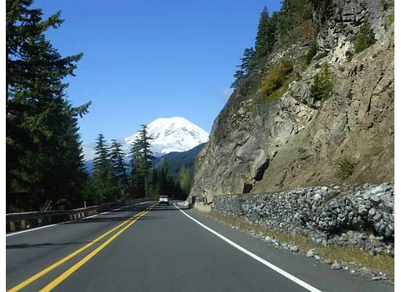
We took the lovely Highway 12 and enjoyed all the twists and turns, the amazing vista of Mt Rainer and the site of a truck hauling a mysterious cargo. After employing the binoculars – not a good thing to do, and the super zoom on my camera – we still couldn’t tell till we passed it – carrots - lots and lots of carrots.
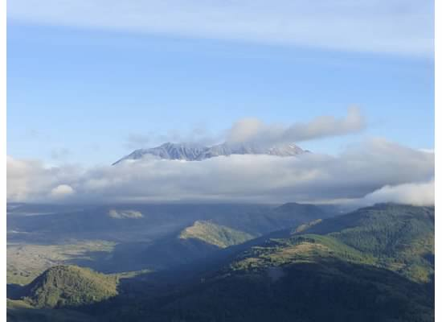
Our big detour was to visit Mt. St. Helens. It is a bit of a drive off the main roads, but well worth the time and effort. It was a beautiful day on the drive, but as we approached the visitor’s center – clouds! No cone viewing for us! But it was a special National Park day so we didn’t have to pay to get in – a nice treat. There are several places to stop along the drive to get different views of the mountain and the path of destruction – which is still evident after all these years. A bit of clearing on the drive out let us see the top.

We planned to cross over at Longview to get on the north coast of Oregon on highway 30. Jan turned the car over to me since it was now dark. Thanks to a local driver whose headlights made it easier to drive – we made excellent time. Jan didn’t speak the whole time – I thought she was listening to our audio book but apparently she was scared for her life and employing the invisible brake. Sadly, I did not see this as it was dark. But we did make good time!

After a quick stop at the Safeway in Astoria – gas points and cheaper groceries than in Long Beach – then we were just a short drive over the Columbia again and into our deluxe townhouse for the week!

Dogs petted: German shepherd

Day 2 – Long Beach

My Birthday! We won’t go into details about that. First order of the day – a visit to the amazing Cottage Bakery that’s been serving up goodies for 40 years! Every visit I’ve looked longingly at the cakes but never got one. Today would be the first – I selected a huge chocolate torte, plus some bread and Jan got some goodies too – after all, we had a week to eat it all.
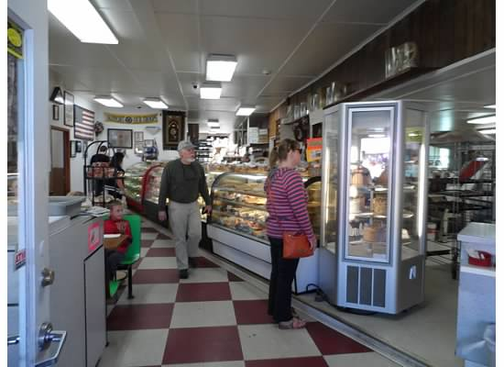

Long Beach is situated on a peninsula at the southern tip of Washington. It does have a long beach that you can explore in many ways – walking the boardwalk, the mostly paved Discovery Trail, and on the beach, by horse and at certain times of the year – by vehicle. The town itself is a nice mix of shops, eateries and museums. They host fun yearly events like the Kite Festival and Sandcastle competition – both are wonderful. For all the details visit funbeach.com.
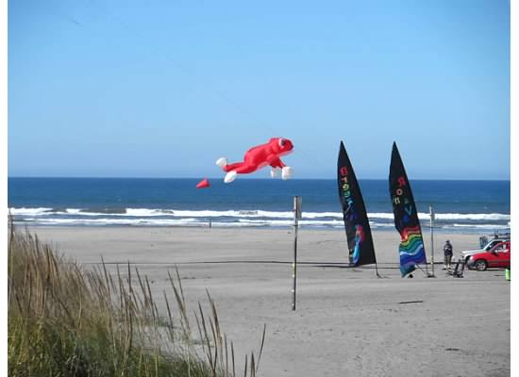

Another beautiful day meant in was time to visit some beaches and drive around and explore. First order of business – walk the boardwalk. This is a nice raised walkway with picnic tables and informational boards on the shipwrecks and local birds. Then we hopped in the car and drove up to visit the quirky Jack’s Mercantile in Ocean Park. This is a grocery/hardware store that is in its original building from 1885. They sell everything from soda to appliances, paint and clamming gear too. I love the old wood cabinets and hardwood floors – it’s like stepping back in time.
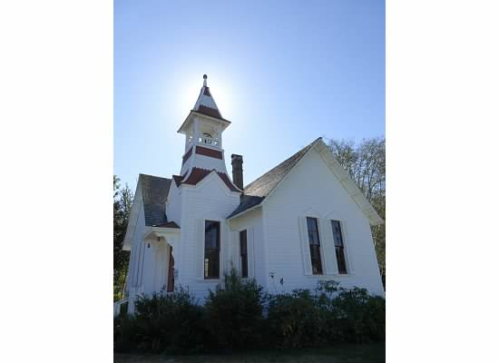
At the northern tip of the peninsula is Oysterville. This was the first settlement in the area and has a row of very stately historic homes, a church and a school. Sadly, none but the church is open to visitors.

Back down the road to visit the beach called Beard’s Hollow. This is a state park so you must get a “discovery” pass for $10 a day or $30 for a year. This has to be purchased at the parking lot of the Cape Disappointment park – so go there first.

After checking the map of how to get to the beach – we went the wrong way. I know, a sad commentary on two MTC IIIs! But I tell you, the map was wrong and after hiking straight up hill, we turned around and found the right way. A nice cove with a rocky beach for great ocean spray photos. On the walk back we were greeted by two very camouflaged frogs and then spotted and eagle soaring overhead!

Dogs petted – Angel the pit bull, scruffy mutt, terrier

Day 3 – Long Beach
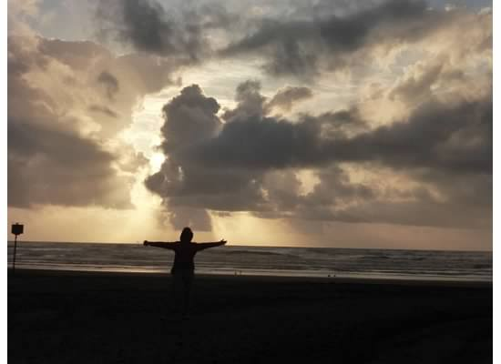
Our first rainy day – but it turned out to be the only one! Quit a rare thing for this time of year. So it was a day of relaxing, beading, movie watching and driving down to the beach for the sunset and sort of causing a young honeymooning couple to get stuck in the sand. But in our continuing efforts to rescue people – we helped them by calling AAA – but they don’t do the sand rescues, but were able to refer us to someone who did and they were out of their trap in 30 minutes.

Dogs petted – pit bull

Day 4 – Astoria

Just before crossing the Columbia again, visit Fort Columbia. A great stop to stretch your legs and experience the old fort grounds. There are two historic buildings offered as vacation rentals. The first is the Steward’s House which can accommodate up to 4 guests. The second is the Scarborough House and it can accommodate up to 12 guests. You can get more information by calling 888-226-7688 or go online.

As we crossed the bridge, we saw a Norwegian cruise ship docked so we were dreading having all those cruisers clogging up the town! But not to worry, things were not crowded. First stop was the Flavel House – a massive historic home that has been restored. One of the first to have indoor plumbing in Astoria – and a couple ghosts, or so they say.
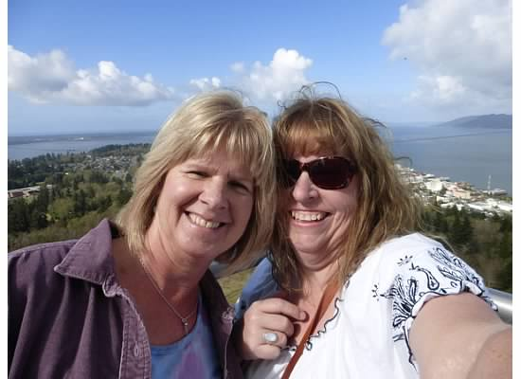

Take a deep breath and then head up the Astoria Column. Only 164 steps and you have a 360 degree view of the area – and being another lovely clear day, we could see forever!

For those of you who are fans of the movie The Goonies – Astoria is where you want to be! The house is still there! Privately owned but kindly allowing us to visit and take a photo! As we are walking to it a guy yells “Hey you guys!” at us. Another young man offered to take our photo and struck up a long conversation about his love of the Goonies. Turns out he was from the cruise ship and had walked from the dock – 5+ miles just to see the house. We offered him a ride back to town with a quick photo stop at the grade school used in the movie Kindergarten Cop. Later that night, Jan got to watch The Goonies for the FIRST TIME! So it was extra cool to point and yell at the screen – we were parked right there! Okay, so maybe it was only extra cool for me
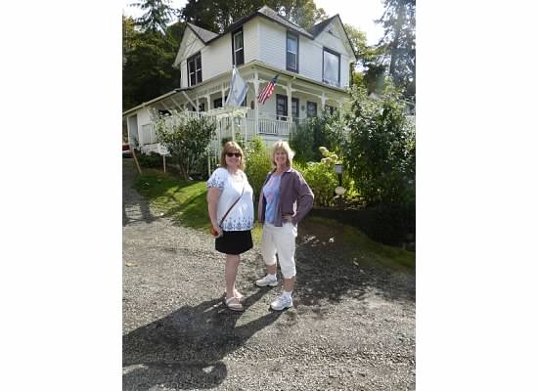

The Columbia River Maritime Heritage Museum is a must see in Astoria. A great history and cool exhibits about early river travel, the events that shaped this port town and even the Coast Guard. Part of your admission includes a visit to the docked Lightship which is quite the experience and not to be missed.

Still enjoying the nice weather, we headed to Fort Stevens at the south jetty of the Columbia. There are several stops in this Fort including one with the remains of a shipwreck.

This evening we had a bit of excitement – for us at least. I went out on our 2nd story deck at about 930pm – pitch dark – and heard some scuffling noises below but couldn’t make out who or what it was. After watching for a few minutes, a creature walked out into the light – I could not believe my eyes – it was a huge black bear! HUGE! Thinking this was an important thing, we called 911. But it turns out this is just Irving the garbage bear on his rounds. We called to a passing cyclist to warn her and she said – oh, there are lots of them. Well, it’s a good thing I was out for a late night walk that night! We spent the rest of the trip grilling locals about this bear situation. No one was concerned!

Dogs petted - Boston Terrier, mastiff puppy, Dalmatian

Day 5 – Long Beach

Today we headed to the famous cranberry museum. We were a bit underwhelmed by it – probably much more interesting when they are harvesting the berries. The museum did have some interesting tools and history about how they gather up the berries – put me down for a no to being a berry harvester! They have a little gift shop some cranberry products to buy which we did – jam! It is free to visit, so not a bad way to learn about this practice.

The main street of Long Beach is a fun collection of stores. We visited a couple stores looking for a good sweatshirt and gifts for folks back home. One of my favorite shops is the Banana Books. They are a tiny used bookstore with an amazing selection of books, three cats and a rescued Pit Bull – Angel. Plus they have espresso and a nice deck with colorful chairs and garden area. I only bought three books this time. Of course, we brought up the bear incident and the owner shared her story of running into him too – she got rid of him by saying “shoo”!

Possibly the strangest attraction in Long Beach – Marsh’s – this is a store plus museum of sorts. They have lots of old time arcade machines that still work so for a nickel you can find out your love rating!
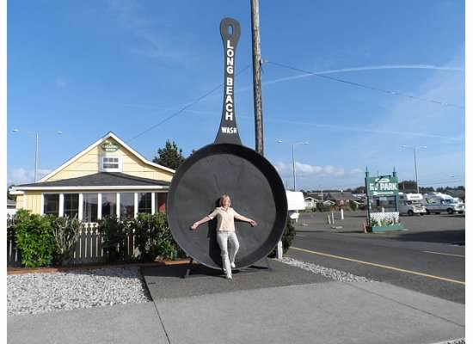
Dinner was enjoyed at the Hungry Harbor. They offer seafood, burgers, shakes, and more. Their items are reasonably priced and very tasty – made to order. We sat outside on the sidewalk to watch passer-byes and you guessed it – pet the pups walking past.

Dogs petted – tried to pet a Scotty dog, he was very aloof, Angel the sweet pit bull and a friendly mutt that probably wanted my cheeseburger!

Day 6 – Oregon Coast
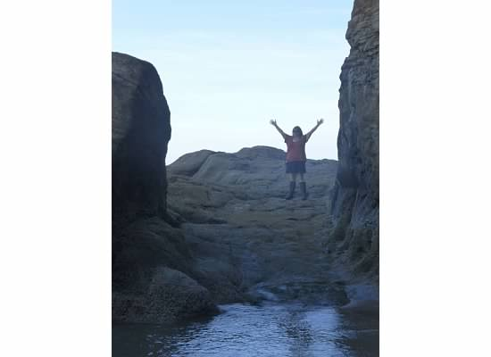
Up early today so we could visit all our stops along the northern Oregon coast. We visited the AAA store in Warrenton to see if they had better Oregon coast maps – no luck.

The first beach of the day was at Hug Point. This is an interesting beach because it has the unique feature of a “road” made out of the rocky hills that was used by stagecoaches! I had never heard or seen this before so I was pretty darn impressed.

Love driving the 101 – curvy, hills, glimpses of the ocean, trees just starting to change colors – a lovely time to drive it! At Tillamook we stopped for lunch at Kendra’s Kitchen a place promising award-winning clam chowder. It’s a quirky old home that’s been converted into a restaurant – be prepared for crooked floors and excellent food. Plus a wiener dog named Turbo! Yes, he was petted!

Cape Mears is just a short drive from Tillamook. It offers a tiny lighthouse you can climb up into and the spectacular Octopus Tree. Just south of here is Oceanside which offers another unique beach feature – a tunnel to a “hidden” beach. Yes, we must brave the tunnel – which can be shut off or dangerous depending on the tides.
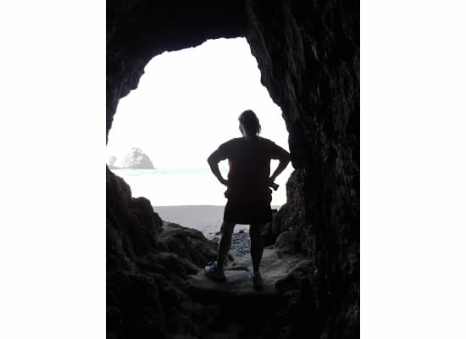

On the return trip to Tillamook, we took a quick detour to see the Munson Falls – another surprise. It is just off the highway a bit and then a short hike to the falls. Very pretty and surrounded by lush forest.

Finally we made it to the Tillamook cheese factory – a must for everyone! You can watch them making the cheese and ice cream and then pick up some for yourself. Even though they’ve stopped making my favorite – white licorice – I was consoled with some vanilla bean and mocha – plus several cheese offerings. Jan secured the required cheese curds for folks back home.

Dogs petted – several beach dogs that came to me – mostly

Day 7 – Seaside
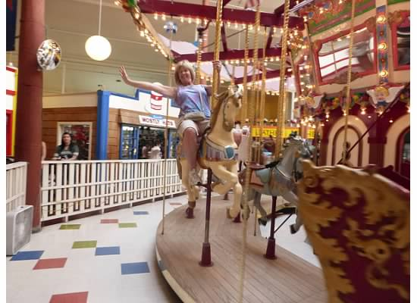

Seaside needed its own day, plus we had to partake of the famous Pig n’ Pancake. Did I get pancakes? Oh yes – sourdough ones which were amazing. Jan selected the chicken fried steak skillet which was enough to feed us both!

And once you’ve eaten your weight in breakfast foods, you must go ride the carousel – well, Jan must. This little mall is cute with the carousel, a fun hat shop and the low-priced shirt store.

A quick jaunt onto the beach and a walk on the promenade where there is plenty to see and do – like the aquarium. We did not visit this time, but its a nice intimate one where you can get up close to the seals and even an octopus! There are a few ocean-view hotels like the Shilo and Best Western that are right at the center of things.

Another great tradition in Seaside – the taffy candy! There are several places that offer this, plus old time candies and chocolates. This is one of the bigger towns on the north coast so there are plenty of accommodations available.
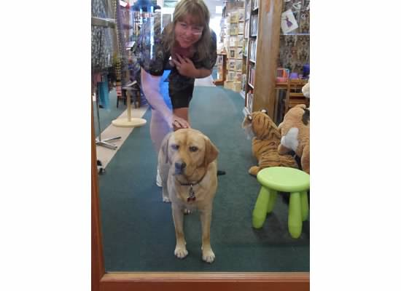
On the way back to Long Beach we stopped at the harbor in Illwaco to secure some oysters and fish tacos for dinner. During the summer months they have a nice craft fair/farmer’s market every Saturday. Today was just the fish market and the book store. A bookstore with the most friendly dog ever! This is Scout and she snuggled with me and brought me her toys to play with. A perfect puppy encounter!

We got back in time to enjoy the Farmer’s market in Long Beach. Just a handful of vendors but we got cranberry juice, goat cheese and listened to music.

Dogs petted – Scout the Lab, two Italian Greyhounds, a Great Pyrenees and a Boxer

Day 8 – Home!

Luckily, the trip back took just 8 hours instead of 14. We really cut our extra trips down. Today we crossed the Columbia four times! We decided on one scenic return – after we picked up our gallons of Sweet Tea at Popeyes! We need one local – anyone have about a million in liquid assets?

We crossed from Oregon back to the Washington side and drove Highway 14 till we took off north at 97 through Toppenish. This was a different return route and a nice alternative to the freeway and big trucks.

Dogs petted – just my own when I got home!

If you want to view all our photos, they are combined at this link:
https://longbeachsept2014.shutterfly.com/pictures/8
